Custom AutoLISP function

Vălcăuan Adina – Diana group 30311

# Description

The created function is called ***TXTBOX***. It draws a box around a selected text, using the polyline function. At the end, it shows an alert message saying “Finished adding the box to the selected text”. Basically, the users write “TXTBOX” in the command line and selects the text.

# The LISP function

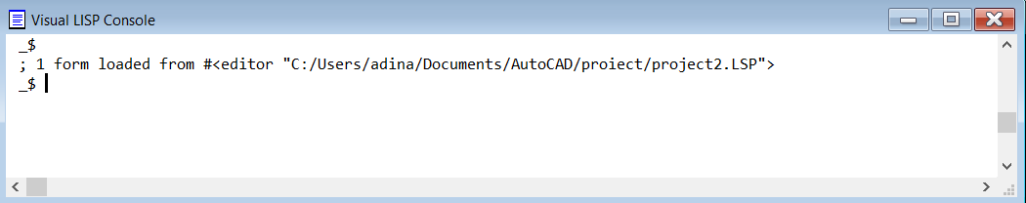

# Running in AutoCAD



